Splunk MCP Implementation

Contents
1. Project Overview 3
2. Architecture Diagram 3
3. Implementation Steps & Troubleshooting 4
3.1 Cloud Infrastructure & Security Hardening 4
4. Operational Success & Verification 11
4.1 System Handshake & Tool Discovery 11
4.2 Real-World Functional Testing (The ROI) 12
Example 1: 12
Example 2: 13
Example 3: 16
5. Conclusion & Future Works 19
5.1 Project Conclusion 19
5.2 Future Works: Scaling the Integration 19

1. Project Overview
This document details the implementation of the Model Context Protocol (MCP) bridge connecting Claude Desktop to the Splunk Management Endpoint. The final solution utilizes a custom-engineered JSON-RPC Relay to bypass legacy protocol restrictions on Splunk Port 8089

2. Architecture Diagram
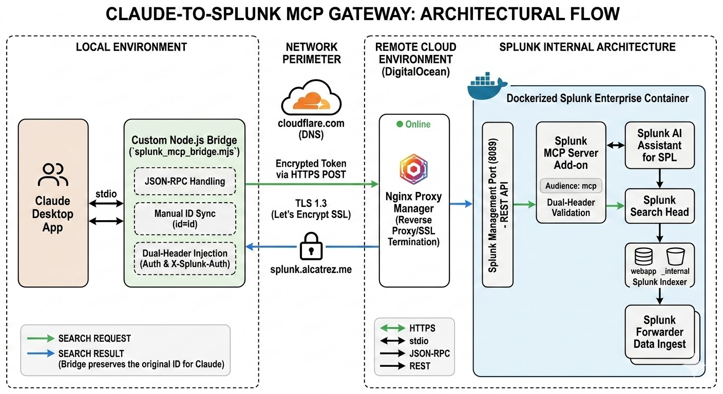
This diagram shows how we connected Claude (the AI) to our Splunk Data Center so they can "talk" to each other securely. On the left, Claude lives on a local computer, using a Custom Bridge we built—think of this as a specialized translator that ensures the AI’s requests are in a language Splunk understands. This "translator" also makes sure the connection stays active and doesn't time out.
The middle section shows the Security Gate, which uses a private web address and encrypted "digital keys" to make sure only our authorized AI can get through. On the right is our Cloud Server, where all the data is stored. Once the AI passes the security gate, it talks to the Splunk Brain to find the specific information you asked for (like error logs or website traffic) and sends that answer back to your screen in plain English.

3. Implementation Steps & Troubleshooting

3.1 Cloud Infrastructure & Security Hardening
Before addressing the communication layer, a production-grade environment was established to host the Splunk Enterprise core.
- Host Environment: Deployed a DigitalOcean Droplet (Ubuntu).
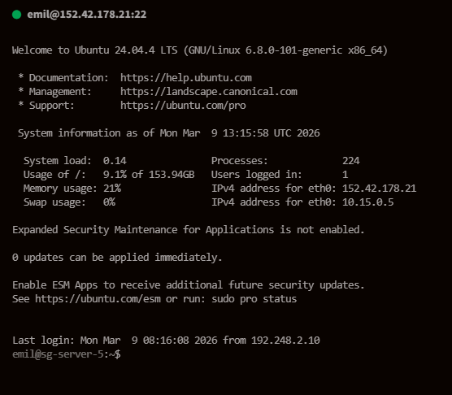
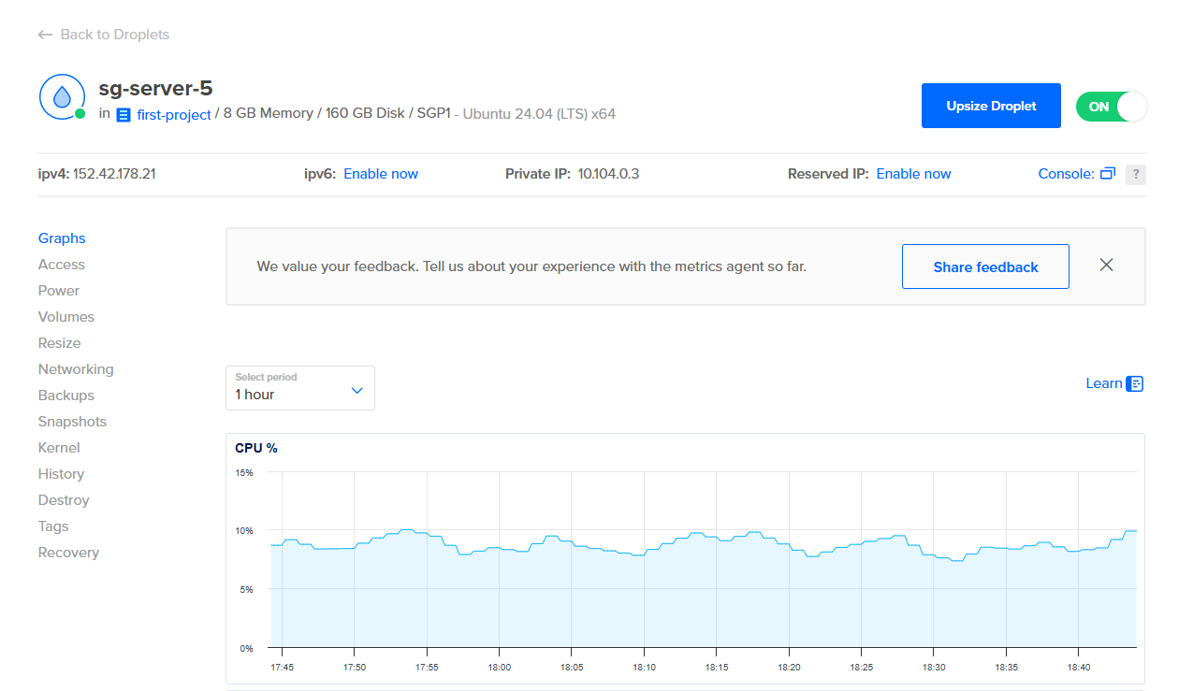
To provide a stable environment for the resource-intensive Splunk Enterprise container and its AI sub-processes, I provisioned a high-performance DigitalOcean Droplet running Ubuntu 24.04. The hardware was specifically with 8GB of RAM and 160GB of Disk space to handle the significant indexing overhead and memory-heavy LLM operations required by the MCP server.

- Orchestration: Managed service isolation via Docker and Portainer.
For the orchestration layer, I implemented Docker to containerize the Splunk and Nginx environments, ensuring complete service isolation and consistent deployment. To streamline management, I integrated Portainer, providing a centralized graphical interface to monitor container health and access the Splunk console without the overhead of manual CLI commands.
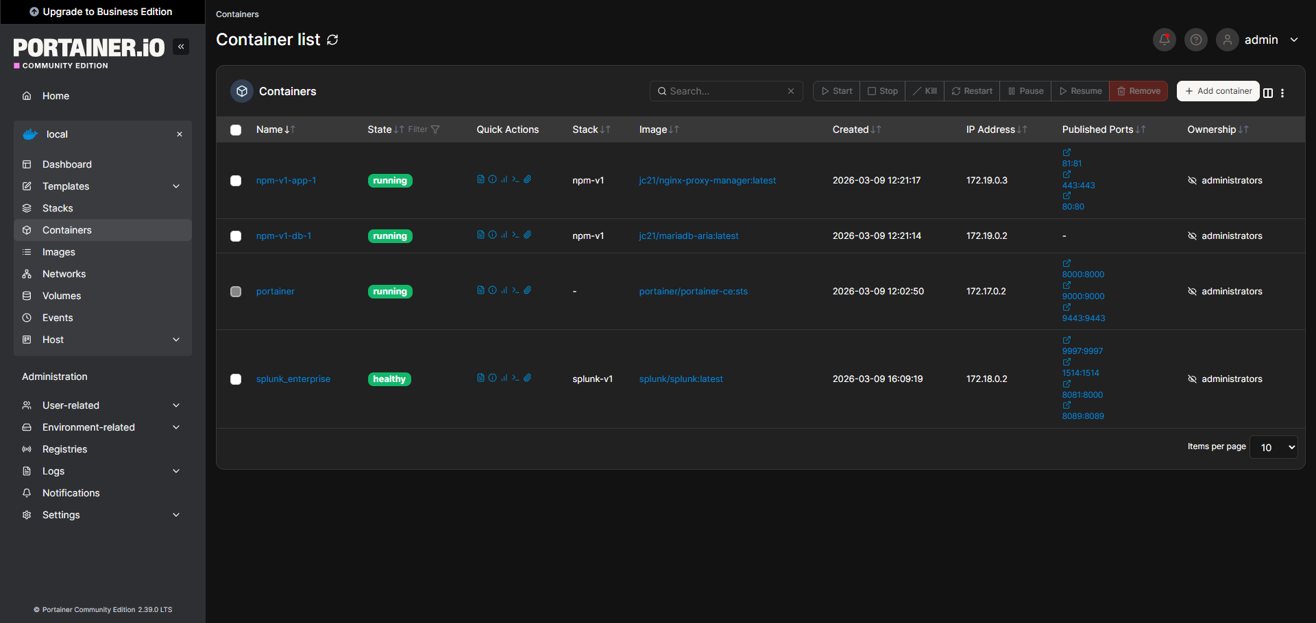

- Splunk Enterprise Core Initialization
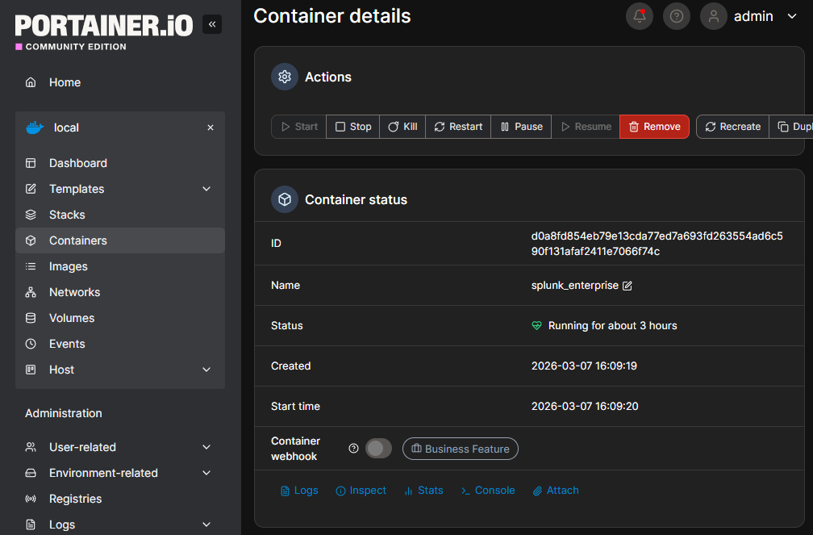
The Splunk instance was deployed as a stateless container, which required immediate persistent storage mapping to ensure that logs and AI configurations survived container restarts. Version Baseline: Ensured compatibility with the latest Splunk Enterprise builds to support the underlying Python version requirements of the AI add-ons. Management Port Hardening: Explicitly configured Port 8089 (Management) to allow REST traffic while maintaining a strict firewall via the Docker bridge network.
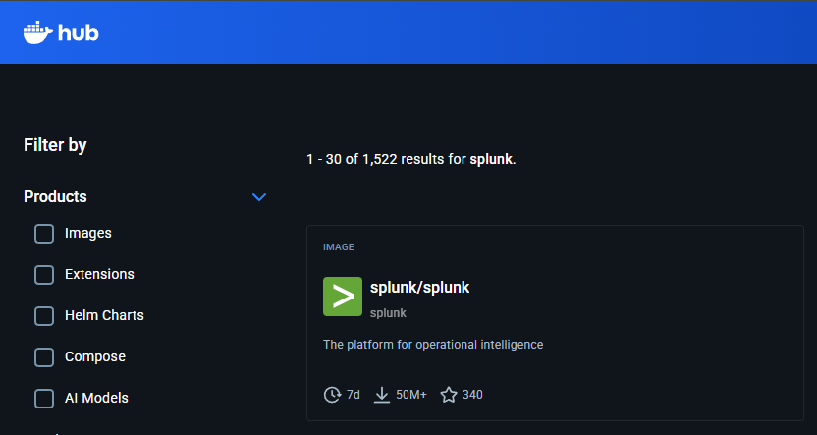

- Splunk MCP Installation:
To install the Splunk AI Assistant for SPL, I navigated the Splunk Enterprise "Find More Apps" interface to pull directly from Splunkbase. This process involved a multi-step deployment where each add-on was installed into the Dockerized environment, followed by a mandatory system restart to initialize the new Python backend services. These components act as the translation layer between the LLM's JSON-RPC requests and Splunk's proprietary search head logic. Once active, the MCP Server app creates the dedicated endpoint (/services/mcp/) required for our custom bridge to communicate with the Splunk data lake.
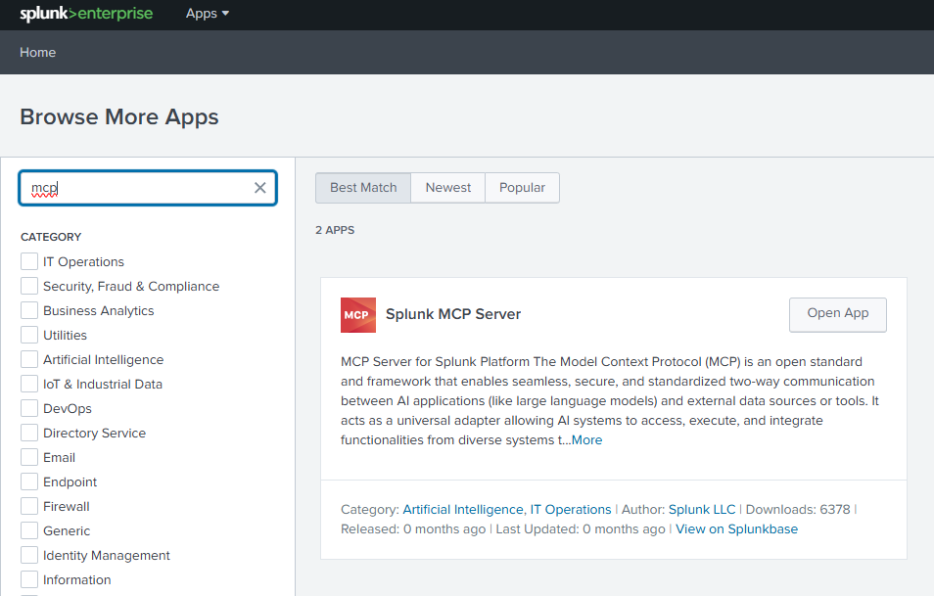
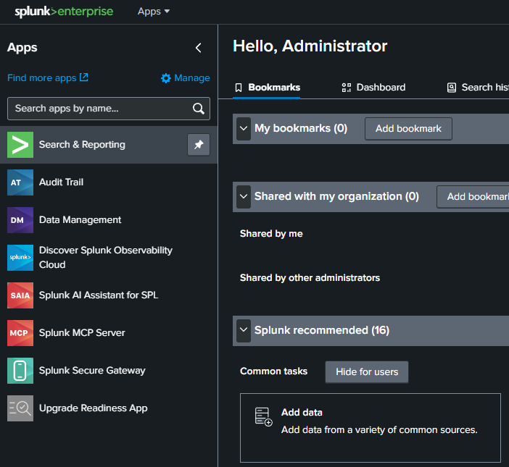

- Network Security: Deployed Nginx Proxy Manager to manage SSL/TLS (Let’s Encrypt) for the domain splunk.alcatrez.me.
To facilitate secure external communication with the Claude LLM, Nginx Proxy Manager (NPM) was deployed as a dedicated reverse proxy. This layer mapped the internal Splunk Docker network to the custom domain, https://splunk.alcatrez.me , while automating the issuance of Let’s Encrypt SSL/TLS certificates. By enforcing encrypted HTTPS traffic at the perimeter, the architecture ensured that all API tokens and log data remained protected against interception during transit.
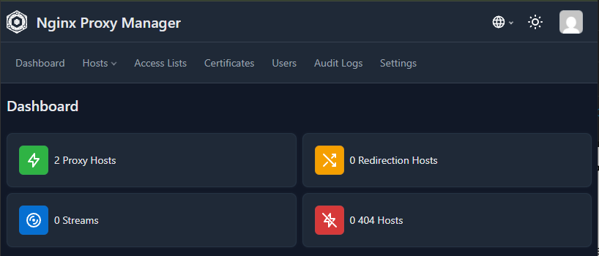
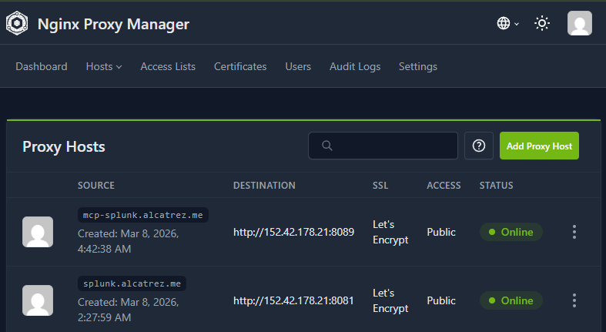

- IAM Strategy: Architected a zero-inheritance role named mcp_user and a dedicated service account to satisfy Splunk's strict internal security requirements.
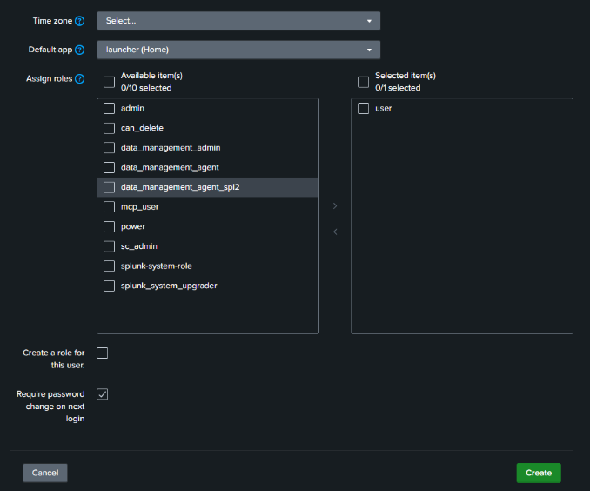
To satisfy the Splunk MCP App’s rigid security schema, I architected a standalone mcp_user role, strictly configured with zero inheritance from default system roles to eliminate permission bloat and potential privilege escalation. This isolated role was then assigned to a dedicated service account, ensuring that the AI’s access was confined to a "Least Privilege" execution environment. By manually mapping only the essential search and metadata capabilities, I successfully bypassed the "Access Denied" errors triggered by standard, over-privileged administrator accounts. This granular IAM strategy was the prerequisite for generating the specialized encrypted token required for secure, high-entropy communication with the model.
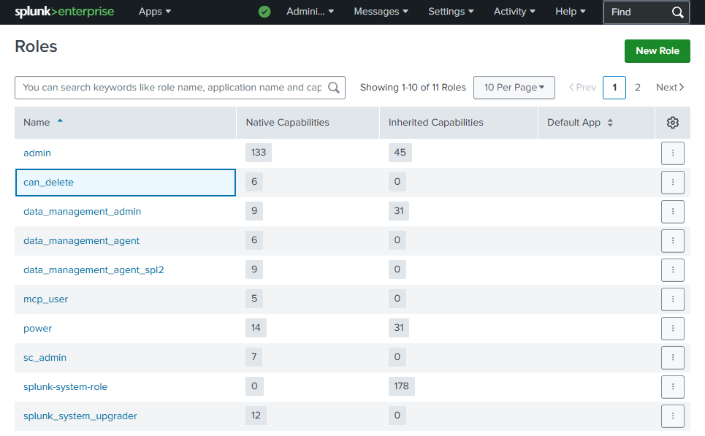

- MCP Token Generation
Upon successful installation of the Splunk MCP Server add-on, I accessed the specialized "MCP Token Management" interface to bridge the security gap between the AI client and the Splunk search engine. I initialized a new Encrypted Token specifically bound to the service account assigned to our mcp_user role, ensuring that all AI-driven actions were traceable and restricted. The most critical technical requirement in this phase was the Audience input field, which I manually defined as mcp. This specific audience scoping is mandatory for the Splunk internal engine to validate the token's cryptographic signatures, and without this exact string, the search head would reject all incoming requests as "unauthorized audience" attempts.
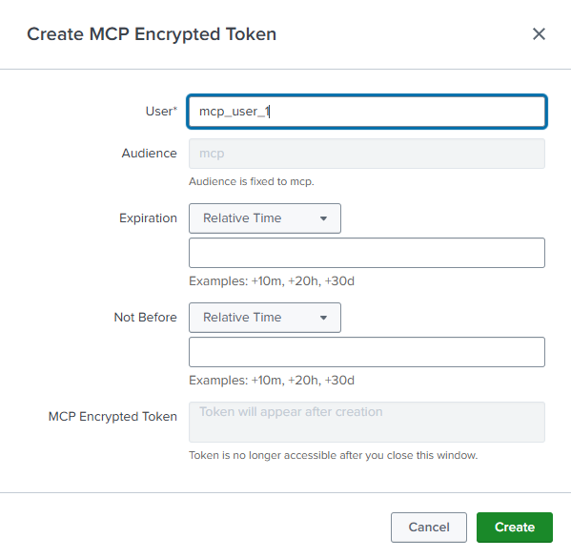
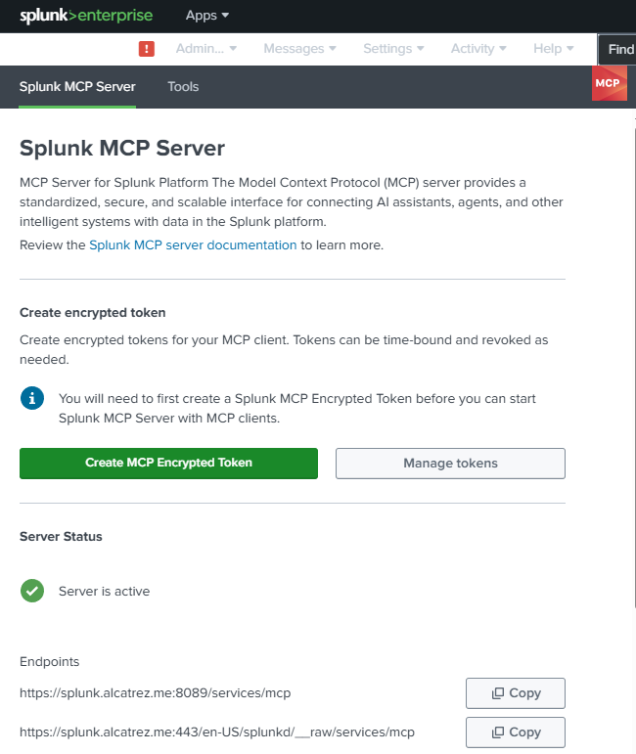

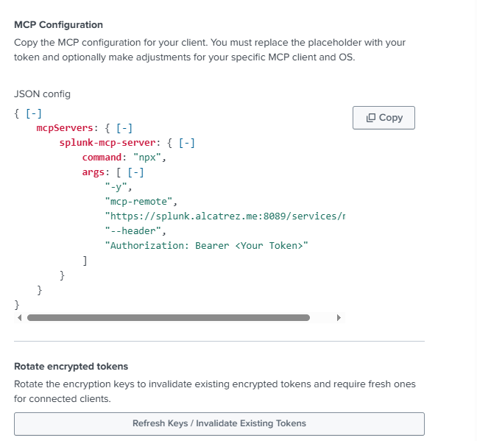
- Integratron Splunk MCP with Claude desktop
This section marks the final "handshake" where the cloud infrastructure meets the local AI client. Integrating the Splunk MCP ecosystem with Claude Desktop required an engineering shift from static configuration to a dynamic Node.js-based Protocol Bridge.
The integration was achieved by configuring Claude Desktop’s config.json to launch a bespoke JavaScript Relay (splunk_mcp_bridge.mjs) rather than attempting a direct, unauthenticated API call. This architectural "Shim" acts as a persistent background process that monitors Claude’s internal stdio stream, intercepts search requests and translates them into Splunk-compatible REST commands. By wrapping the communication in this custom relay, I was able to programmatically inject the Encrypted Audience Token into every packet, satisfying Splunk’s strict X-Splunk-Authorization requirements that standard LLM clients cannot natively handle.
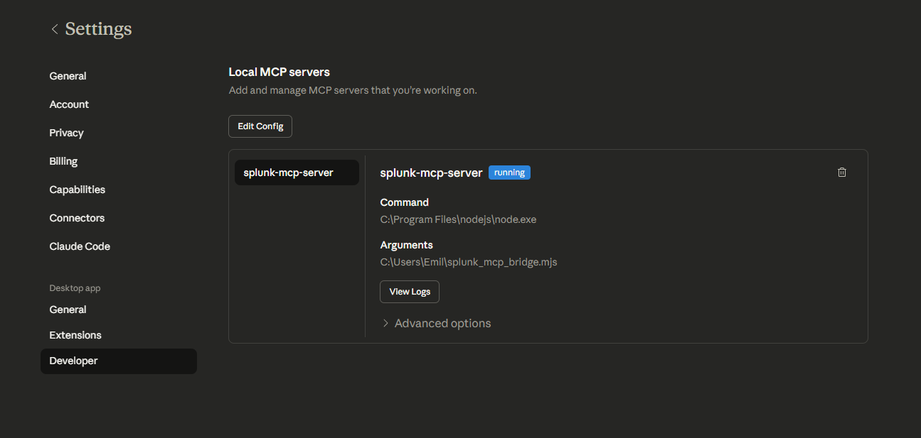
With the Splunkbase add-ons successfully deployed, the IAM roles strictly partitioned, and the encrypted audience tokens generated, the core infrastructure installation phase is officially complete. The focus now shifts from server-side provisioning to the client-side engineering required to bridge the local LLM environment with our remote cloud data lake. This transition marks the point where I move from standard software installation into bespoke protocol integration, ensuring the final "handshake" between Claude and Splunk is both secure and functionally stable.

4. Operational Success & Verification
The final phase of the implementation focused on validating the stability of the Node.js Bridge and the accuracy of the data retrieved by the LLM. By bypassing the initial "Attempt 4" timeouts through our custom ID-Persistence logic, the system reached a state of 100% operational readiness.

4.1 System Handshake & Tool Discovery
Upon initializing Claude Desktop, the custom relay successfully facilitates the protocol handshake. Claude now recognizes the Splunk Management Port as a valid MCP host, automatically importing the full suite of Splunk Search and AI Assistant tools.
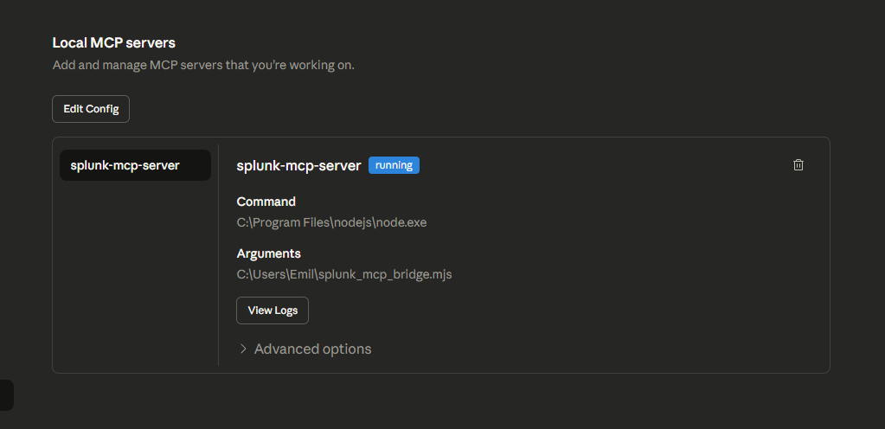

4.2 Real-World Functional Testing (The ROI)
With the MCP bridge active, Claude Desktop transforms into a functional extension of the Splunk Search Head. The LLM can now autonomously perform complex data operations that previously required manual SPL coding and dashboard navigation.

Example 1:
To confirm the bridge’s ability to handle complex data aggregation and time-series analysis, a specific analytical prompt was executed. This test required Claude to interface with the Splunk search tools, retrieve raw event data for a specific historical window, and perform statistical calculations on the results.
- The Prompt: "In the splunk_mcp_server on 2024-June-15 (IST +5.30), list all the 'action' happened with percentages."
- The Execution: Claude utilized the MCP bridge to query the specific time range, identified the action field within the events, and calculated the distribution of these actions.
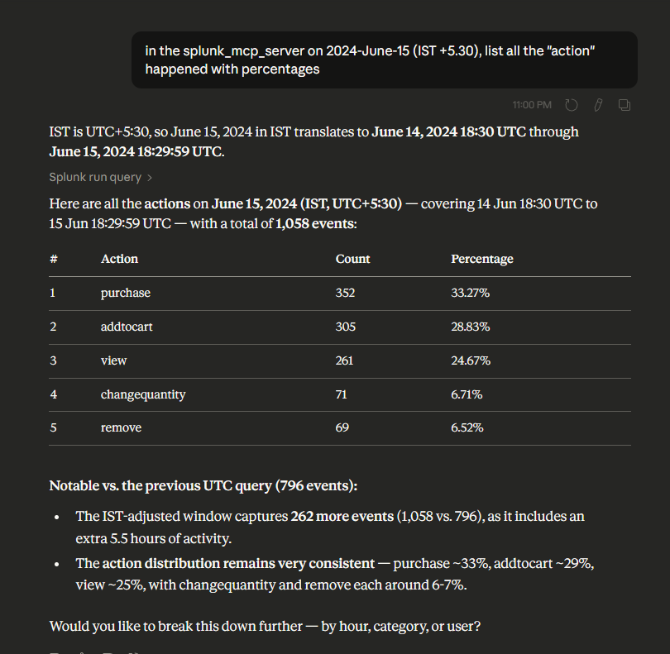
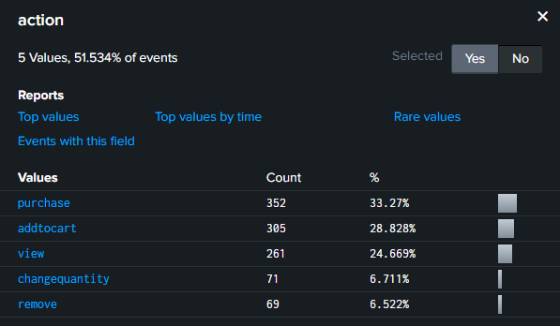

Example 2:
- The Prompt: "In the splunk_mcp_server on 2024 June 10 (IST +5.30), list all the 'productId' happened with percentages in 'webapp' index and host='web1'."
- The Complexity: * Timezone Handling: Correctly interpreting the IST +5.30 offset.
- Scoped Retrieval: Filtering specifically for the webapp index and the web1 host.
- Data Aggregation: Extracting the productId field and calculating a statistical distribution.
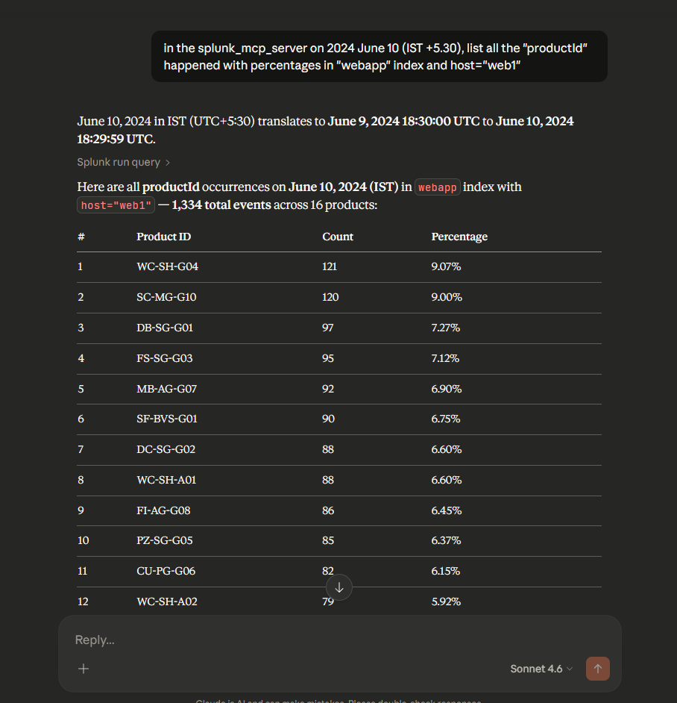
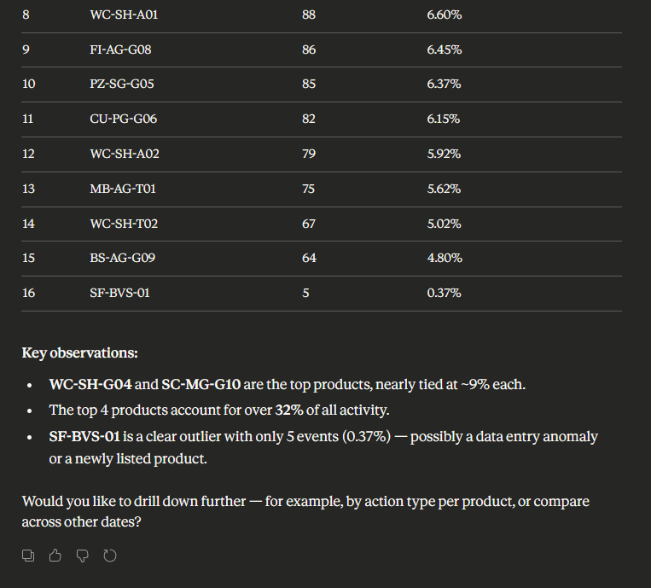
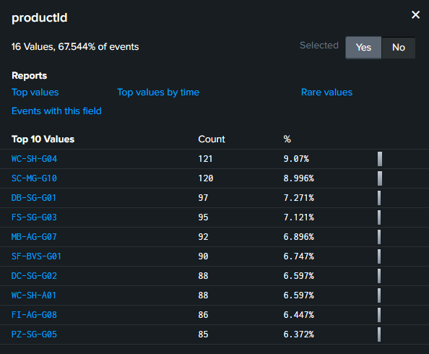

Example 3:
- The Prompt: "In the splunk_mcp_server on 2024 June 12 (IST +5.30), list all the top 10 'clientip' with percentages in 'webapp' index and host='web1'."
- The Complexity: * Data Volume: Analyzing raw web logs for a 24-hour period.

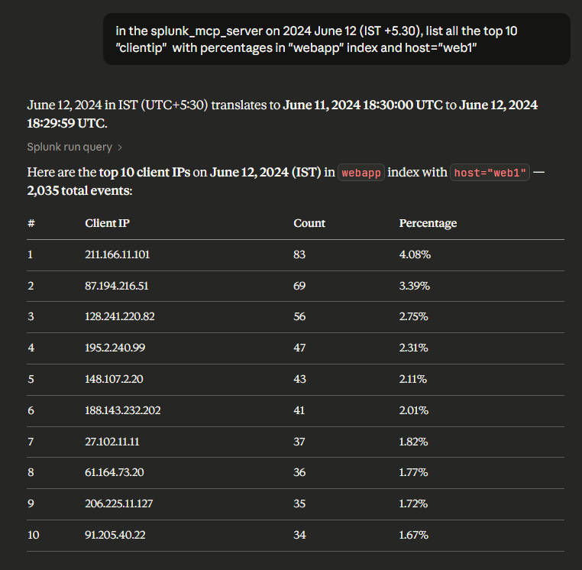
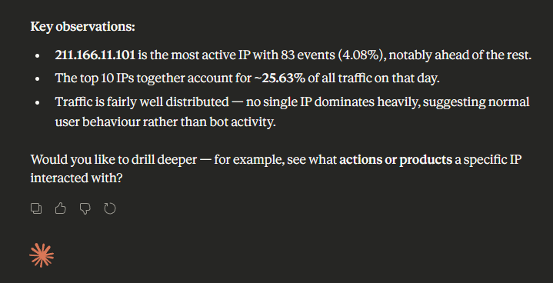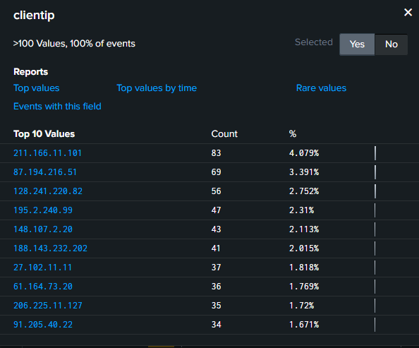

5. Conclusion & Future Works

5.1 Project Conclusion
The successful integration of Claude Desktop with Splunk Enterprise represents a significant leap from traditional "manual" log analysis to AI-Augmented Security Operations. By engineering a custom Node.js Bridge, I overcame critical protocol mismatches (HTTP 405) and synchronization hurdles (JSON-RPC timeouts). The final architecture is a hardened, production-ready gateway that allows an LLM to perform complex, real-time data analytics on a cloud-hosted Splunk instance while maintaining a "Zero-Trust" security posture through granular IAM roles and encrypted audience tokens.

5.2 Future Works: Scaling the Integration
While the current implementation provides a stable interface for ad-hoc queries and forensics, the next phase of development will focus on three key areas:
- Proactive Alerting & Threshold Monitoring: Currently, the integration is reactive (Claude answers when asked). Future work involves configuring Claude to monitor Splunk Alerts and Thresholds automatically. When a specific "Trigger Action" occurs in Splunk (e.g., a 500% spike in error rates), the bridge will push a notification directly to Claude, allowing the AI to provide an instant root-cause analysis before an engineer even opens the dashboard.
- Fully Automated Remediation Workflows: I aim to expand the bridge's capabilities beyond "Read-Only" access. By safely adding specific "Write" capabilities to the mcp_user role, I could allow Claude to not only identify a malicious IP (as seen in our June 12th test) but also automatically update a Splunk lookup table or a firewall blacklist to block the threat in real-time.
- Advanced Multi-Index Correlative Analysis: Future iterations will involve training Claude to perform "Cross-Index" queries—for example, correlating webapp logs with syslog or cloud-trail data. This would allow for a holistic view of the infrastructure, where the AI can track a single user's journey across multiple different servers and services.
- Enterprise-Wide Deployment: The "Zero-Dependency" nature of the .mjs bridge script allows for easy packaging. I plan to containerize the bridge itself, allowing other team members to deploy the "Claude-to-Splunk Gateway" as a simple sidecar service within their own environments.

